**DAILY ONLINE ACTIVITIES SUMMARY**

|  |  |  |  |  |  |  |  |  |
| --- | --- | --- | --- | --- | --- | --- | --- | --- |
| **Date:** | **30 June 2020** | | | | | **Name:** | **K ISHA HEGDE** | |
| **Sem & Sec** | **4th sem, 2nd year** | | | | | **USN:** | **4al18cs031** | |
| **Online Test Summary** | | | | | | | | |
| **Subject** | | **---** | | | | | | |
| **Max. Marks** | | **----** | | **Score** | | | **---** | |
| **Certification Course Summary** | | | | | | | | |
| **Course** | **CASE STUDIES FROM RETAIL & E-COMMERCE** | | | | | | | |
| **Certificate Provider** | | | **GreatLearning** | | **Duration** | | | **10hours** |
| **Coding Challenges** | | | | | | | | |
| **Problem Statement:3 program** | | | | | | | | |
| **Status: Executed** | | | | | | | | |
| **Uploaded the report in Github** | | | | | **Yes** | | | |
| **If yes Repository name** | | | | | <https://github.com/iishaii/locked-down_coding> | | | |
| **Uploaded the report in slack** | | | | | **Yes** | | | |

#### *Certification Course Summary:*

Today I started with **CASE STUDIES FROM RETAIL & E-COMMERCE** in Great Learning which is of 10hrs. After the completion of course, certificate will be provided. The topics I covered are

* Retail analytics using predictive modelling & machine learning
* Predicting YoY retail sales value using time series forecasting
* Application of analytics in e-commerce



***Coding Challenges:***

Today I solved 3 coding challenge,

**1.Write a C Program to check whether the number is Ugly or not.**

Ugly numbers are those number whose prime factors are 2, 3 or 5. From 1 to 15, there are 11 ugly numbers 1, 2, 3, 4, 5, 6, 8, 9, 10, 12, 15. The numbers 7, 11, 13 are not ugly because they are prime. The number 14 is not ugly because in its prime factor the 7 will come.

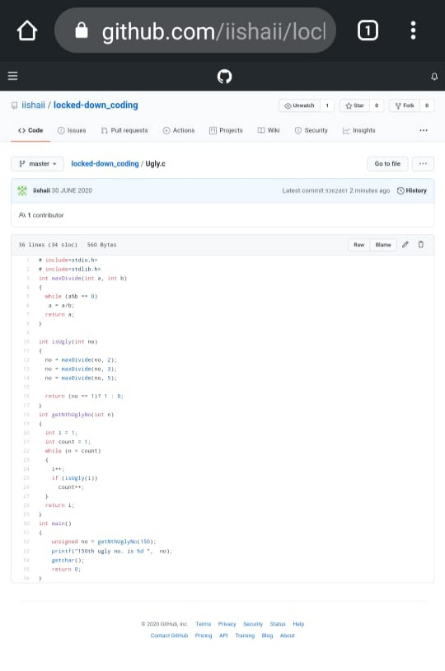

**2.** **Write a C Program to generate first n Ugly Numbers**

Ugly numbers are those number whose prime factors are 2, 3 or 5. From 1 to 15, there are 11 ugly numbers 1, 2, 3, 4, 5, 6, 8, 9, 10, 12, 15. The numbers 7, 11, 13 are not ugly because they are prime. The number 14 is not ugly because in its prime factor the 7 will come.

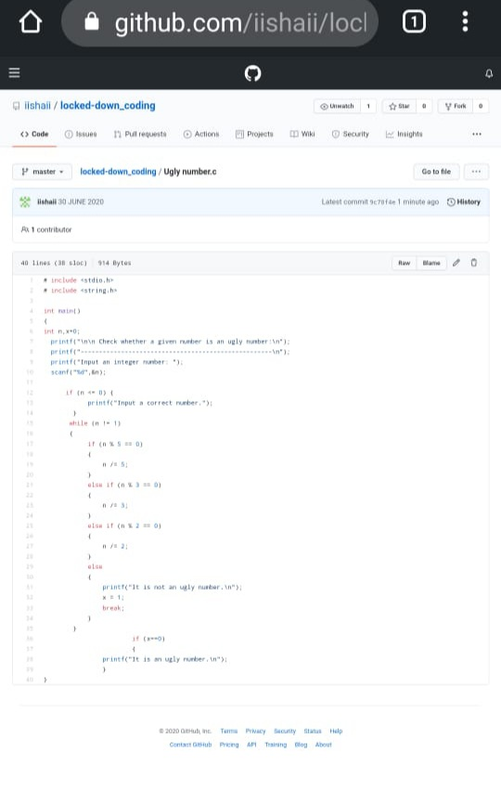

**3.** **Write a C++ Program to Move all zeroes to end of array using Two-Pointers**

Given an array of random numbers, Push all the zero’s of the given array to the end of the array. For example, if the given arrays is {1, 0, 2, 6, 0, 4}, it should be changed to {1, 2, 6, 4, 0, 0}. The order of all other elements should be the same.

Examples:

Input: arr[]={8, 9, 0, 1, 2, 0, 3}  
Output: arr[]={8, 9, 1, 2, 3, 0, 0}  
Explanation:  
Swap {0 ,1} -> Resulting array {8, 9, 1, 0, 2, 0, 3}  
Swap {0 ,2} -> Resulting array {8, 9, 1, 2, 0, 0, 3}  
Swap {0 ,3} -> Final array {8, 9, 1, 2, 3, 0, 0}

Input: arr[]={4, 5, 0, 0, 0, 0, 6, 7}  
Output: arr[]={4, 5, 6, 7, 0, 0, 0, 0}

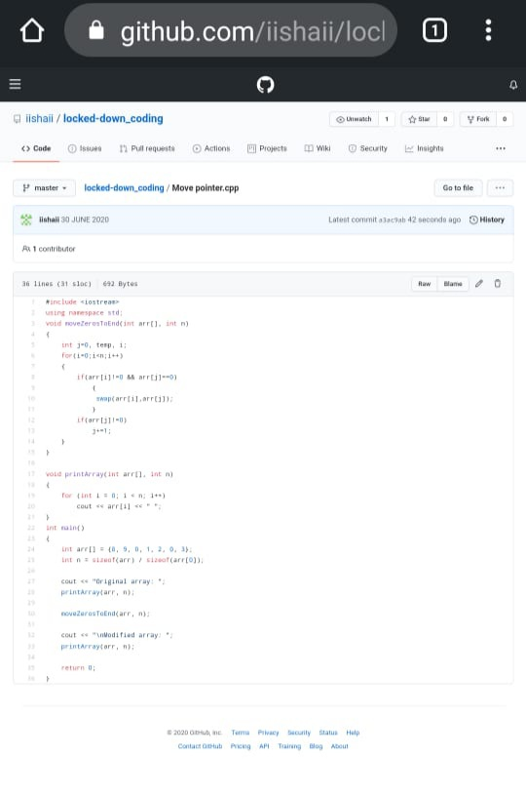

***Extra Activity:***

Today I attended Online training on C++ from 12:00-2:00 PM.

Quizzes are conducted at the end of the class.